**Introduction:**

This document explains the detailed steps followed for submitting the Homework for the project - Unit18_Blockchain.

**Detailed Steps:**

**Step-1: Download Software:**

* Download and install MyCrypto app from website: <https://download.mycrypto.com/>
* Download Ethereum Tools from website: <https://geth.ethereum.org/downloads/>

Download ‘Geth & Tools 1.9.19 for Windows 64-bit, extract it to the project folder and rename the folder name to - KSBlockchain-Tools

**Step-2: Setup a testnet blockchain**

* Open Git Bash
* Go to Folder using CD C:/Users/kscho/Documents/github_files/Unit18_Blockchain/KSBlockchain-Tools
* Run the following commands in sequence and note the info
* Create node1 using ‘geth’
  + ./geth account new --datadir node1

Enter PW: fintech828a

Public address of the key: 0xfEE14C1Ba13a3B379894F344aD6E375c4a605fFD

Path of the secret key file: node1\keystore\UTC--2020-08-28T21-35-06.801720700Z--fee14c1ba13a3b379894f344ad6e375c4a605ffd

* Create node2 using ‘geth’
  + ./geth account new --datadir node2

Enter PW: fintech828a

Public address of the key: 0x1Dc3F31731149b42eafefb3D110DF3A4D03f5FD6

Path of the secret key file: node2\keystore\UTC--2020-08-28T21-37-35.247089800Z--1dc3f31731149b42eafefb3d110df3a4d03f5fd6

* Create blockchain network using ‘puppet’
  + ./puppet

Enter Network name as: fintech828a

Choose option: 2. Configure new genesis

Choose option: 1. Create new genesis from scratch

Choose consensus engine to use = 2. Clique – proof-of-authority

Hit enter for time (Default = 15)

Enter accounts for seal: Public Address of both nodes (exclude first 2 digits)

Enter accounts for pre-funding: Public Address of both nodes (exclude first 2 digits)

Enter ‘no’ for pre-funding with 1 wei

Hit Enter

Hit Enter

Enter yes

Enter 8282 ( chain/network ID)

Hit Enter

Hit Enter

Check the folder for newly created fie: fintech828a.json file (delete the 2nd .json file)

* Initialize the nodes
  + ./geth init fintech828a.json --datadir node1
  + ./geth init fintech828a.json --datadir node1
* Run the first node, unlock the account, enable mining, and the RPC flag
  + ./geth --datadir node1 --mine --minerthreads 1
  + Copy the ‘enode’
  + enode://cde1535a71815fefbeb5386fef62a6821314a0f991f523d4999762d566b93abdf1c05e75b6c15925d90ff98cf7be916877315ed41dbdd3351bb36cc30fc5edeb@127.0.0.1:30303
* Open another Git Bash console and go the folder and Run the second node
  + ./geth --datadir node2 --port 30304 --rpc --bootnodes "enode:..” --ipcdisable
  + Use the first node’s ‘enode’ in the above command
* Open MyCrypto App
  + Change node
  + Add custom node
  + Enter Node name = fintech828a, Network = Custom,. Network name = fintech828a, Currency = ETH, Chain ID =822, URL = <http://127.0.0.1:8545>
  + Click on button – Save & Use Custom Node
  + Enter node1 Keystore file details for Wallet
  + Enter Password for the node1

Wallet Info:

Public Address: 0xfEE14C1Ba13a3B379894F344aD6E375c4a605fFD

Public Address: 0xfee14c1ba13a3b379894f344ad6e375c4a605ffd

Private Key:

Balance: 0 ETH

* Transfer Money from <https://faucet.kovan.network/>
* Check the balance in MyCryto Wallet, Now it has ETH enough to make a transfer
* Transfer Money from MyCrypto Wallet

From Account (node1): 0xfEE14C1Ba13a3B379894F344aD6E375c4a605fFD

To Account (node2): 0x1Dc3F31731149b42eafefb3D110DF3A4D03f5FD6

Amount to Transfer 15 ETH

Your TX has been broadcast to the network. It is waiting to be mined & confirmed. During ICOs, it may take 3+ hours to confirm. Use the Verify & Check buttons below to see. TX Hash:0x50bcbfbcb124736af0664216a44a585ac583a24ee07c32aeccc1563a2f8f50a6

Hash: 0x50bcbfbcb124736af0664216a44a585ac583a24ee07c32aeccc1563a2f8f50a6

Appendix

Picture showing MyCrypto App:

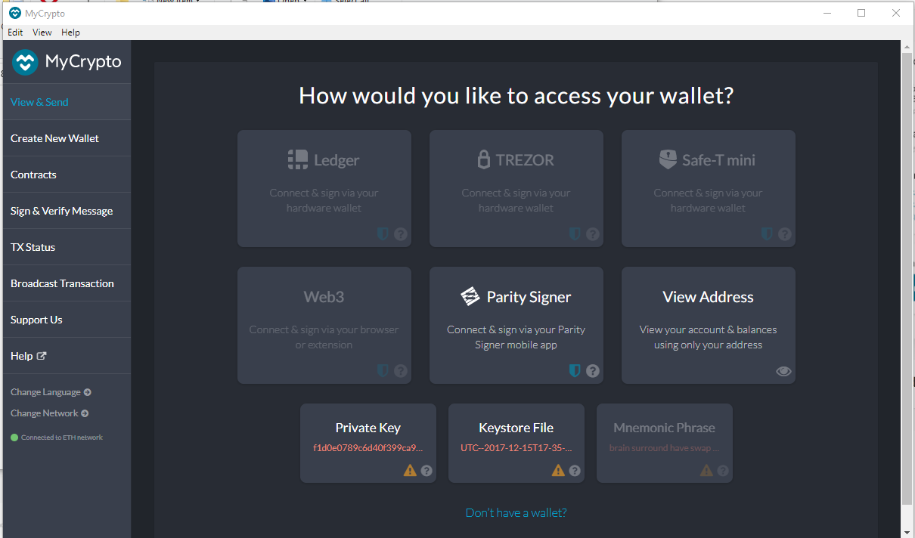

Picture showing contents for folder - KSBlockchain-Tools:

The folder name is: C:/Users/kscho/Documents/github_files/Unit18_Blockchain/KSBlockchain-Tools

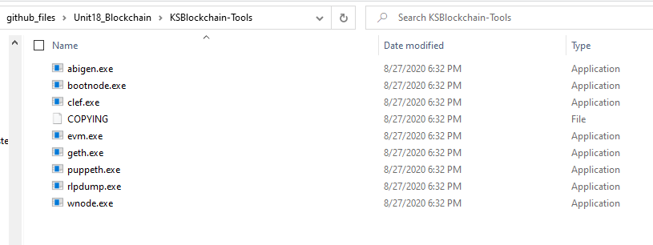

Picture showing ‘geth’ nodes

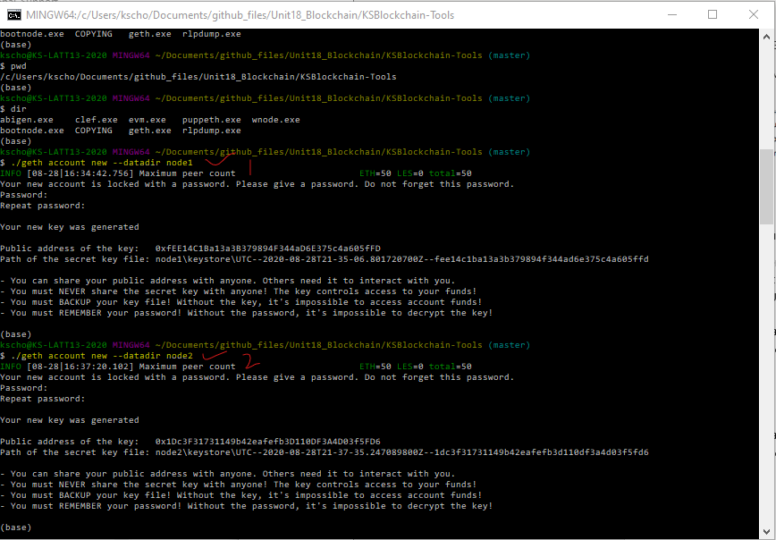

Picture showing creation steps of Blockchain network

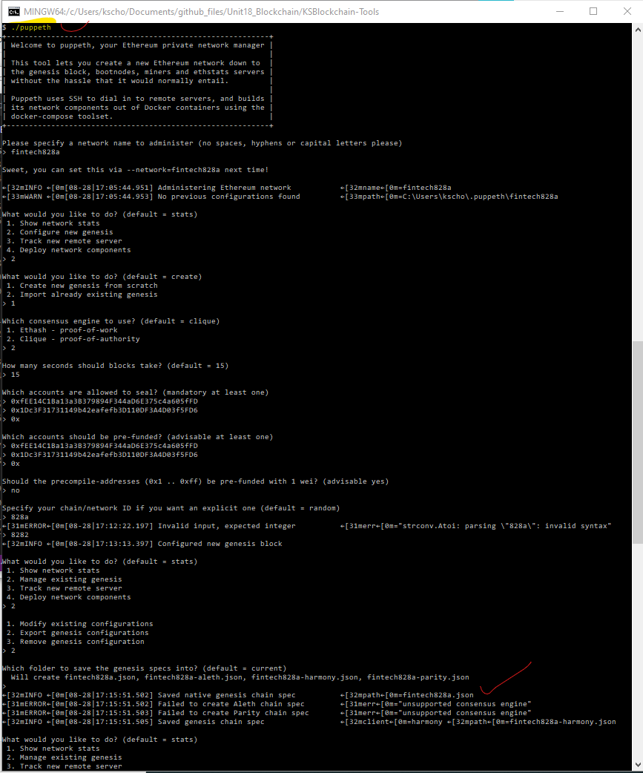

Picture showing console after creating the 2 json files (also see the datadir for 2 nodes)

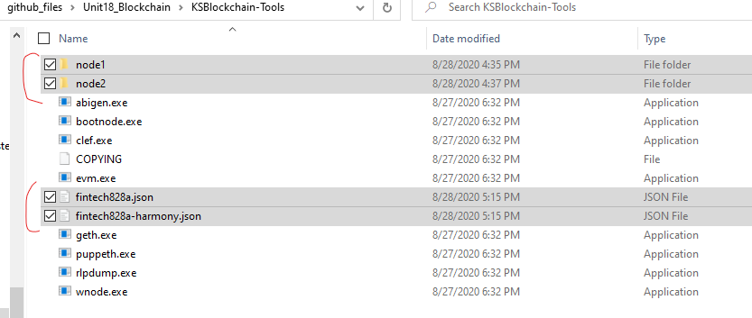

Picture showing the console after initializing the nodes

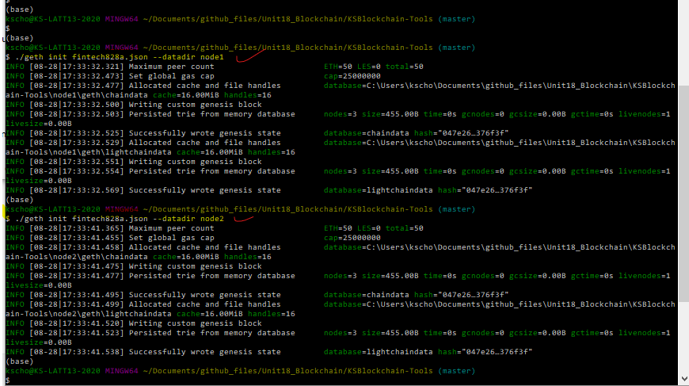

Picture showing node1 and its enode

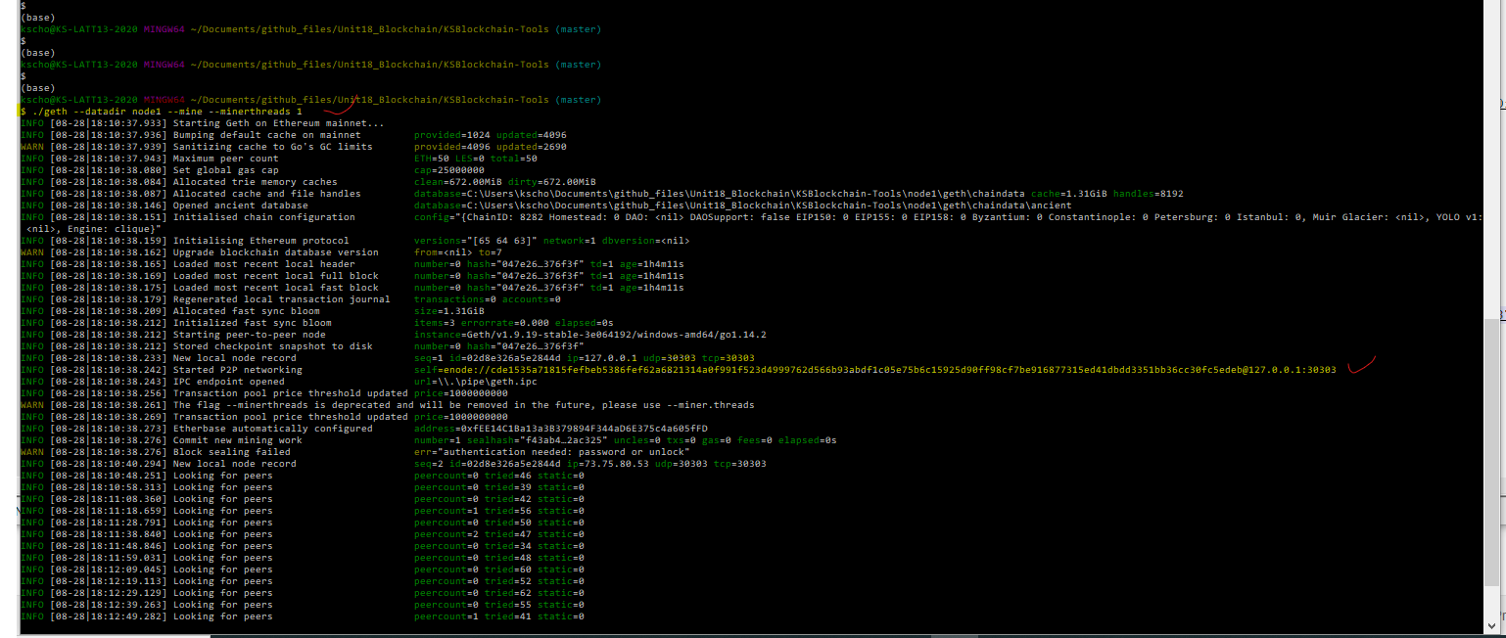

Picture showing node2 mining

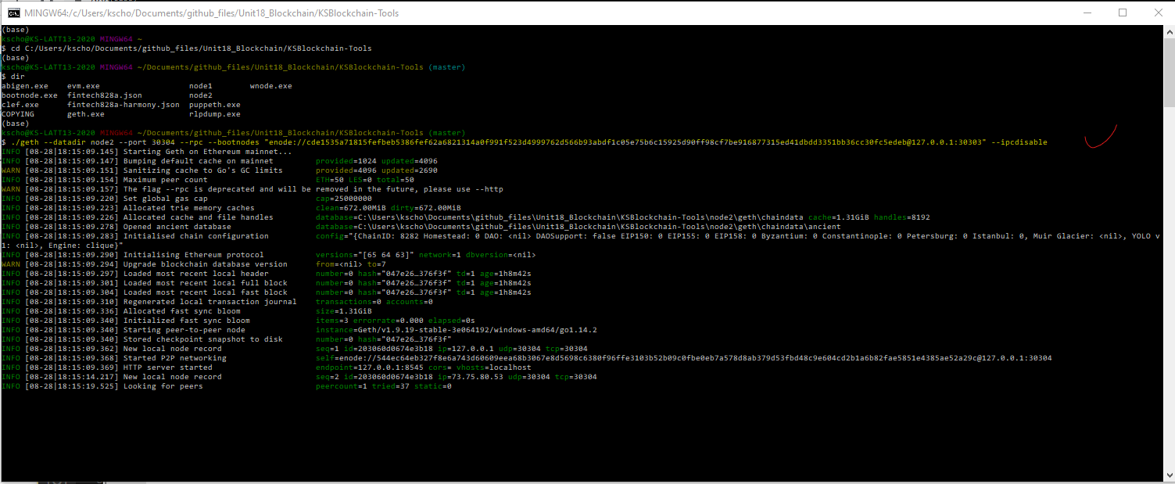

Picture showing both node1 and node2 mining

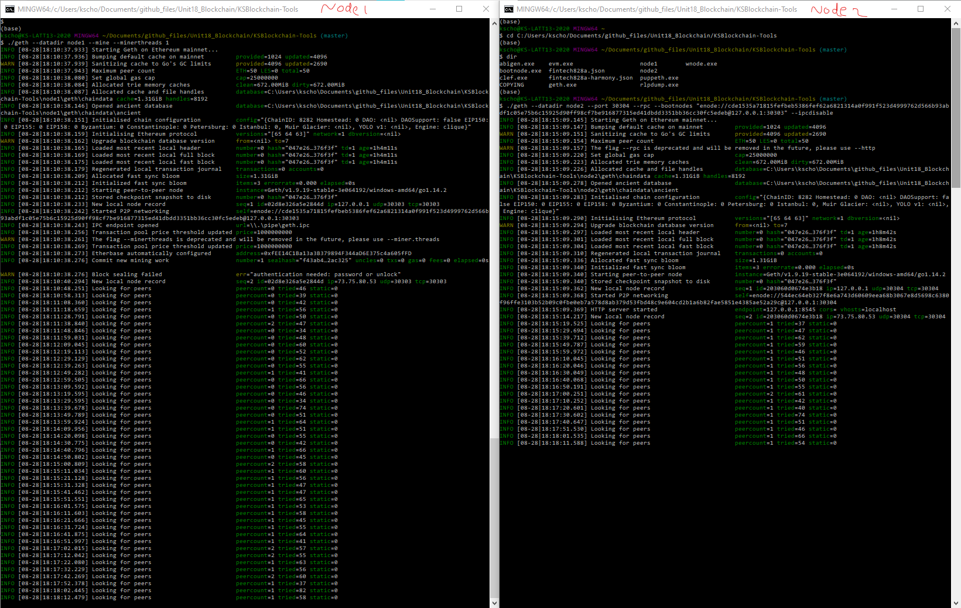

Picture showing MyCrypto – Adding custom node

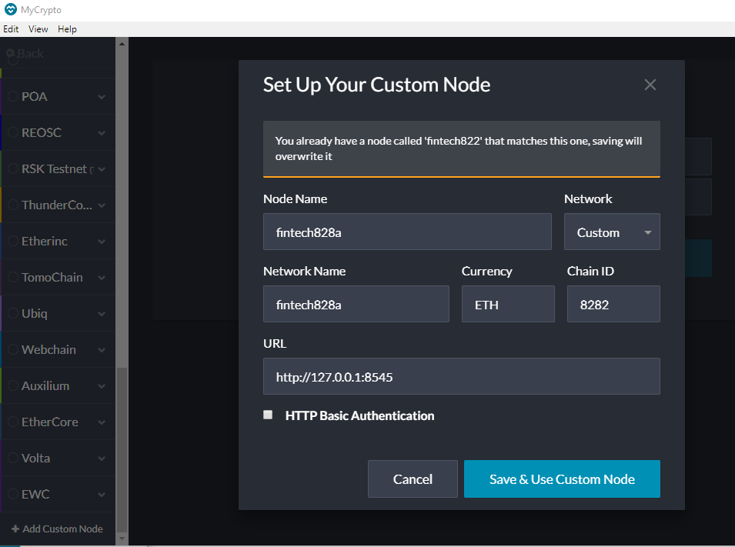

Picture showing MyCrypto Wallet

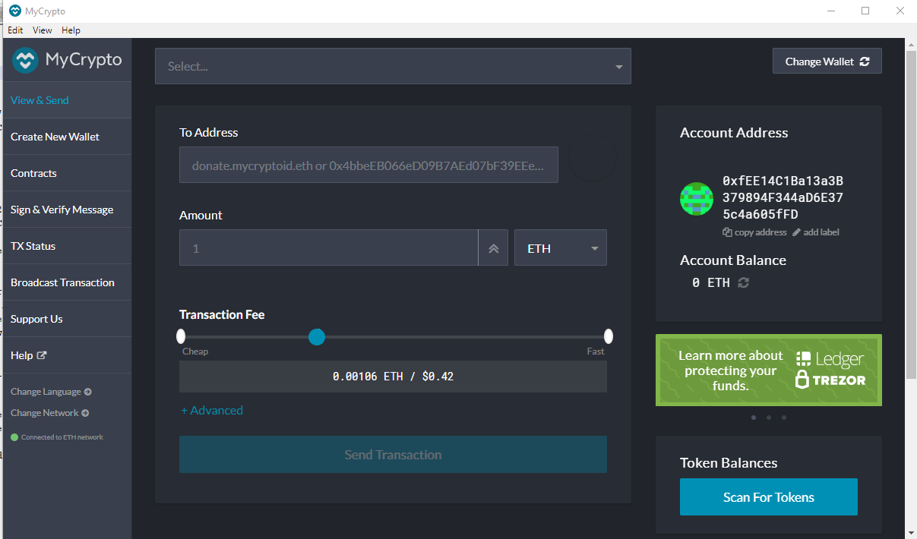

Picture showing MyCrypto Node

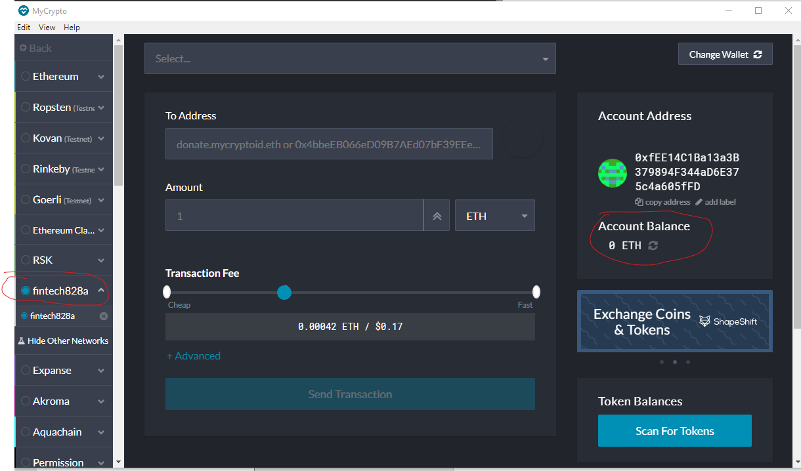

Picture showing Transfer of 1 ETR from Kovan Testnet

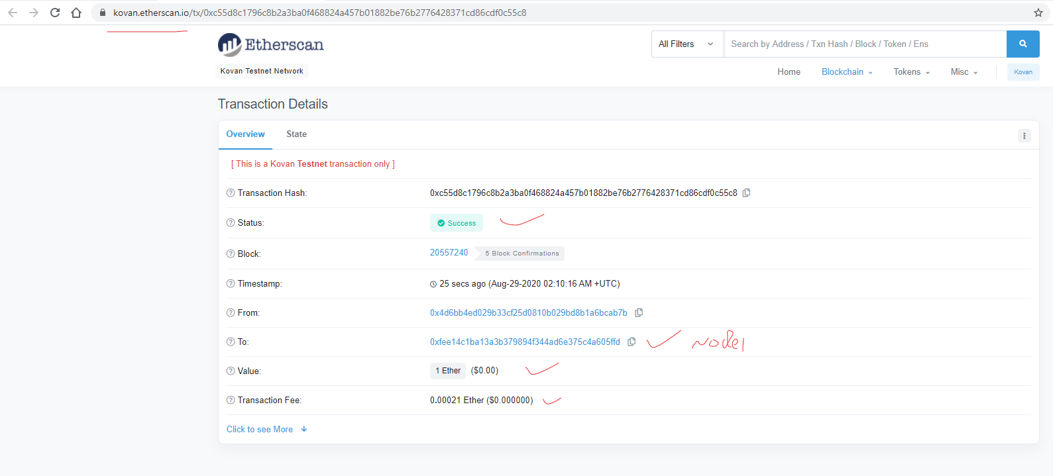

Picture showing new balance after the above transfer

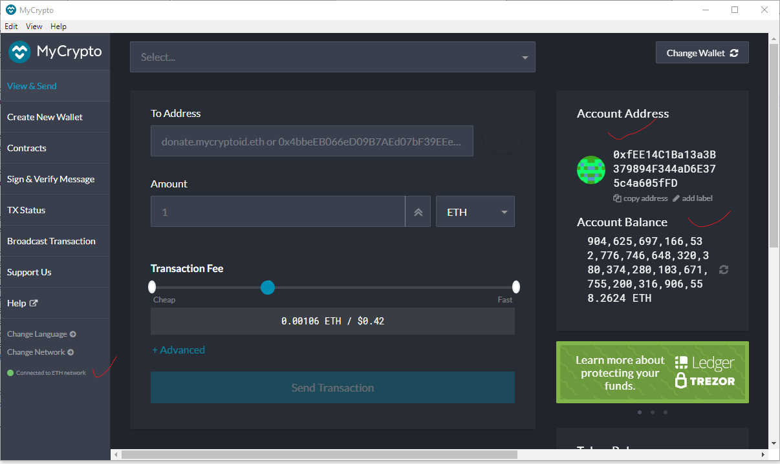

Picture showing the Transfer from node1 account to node2 account

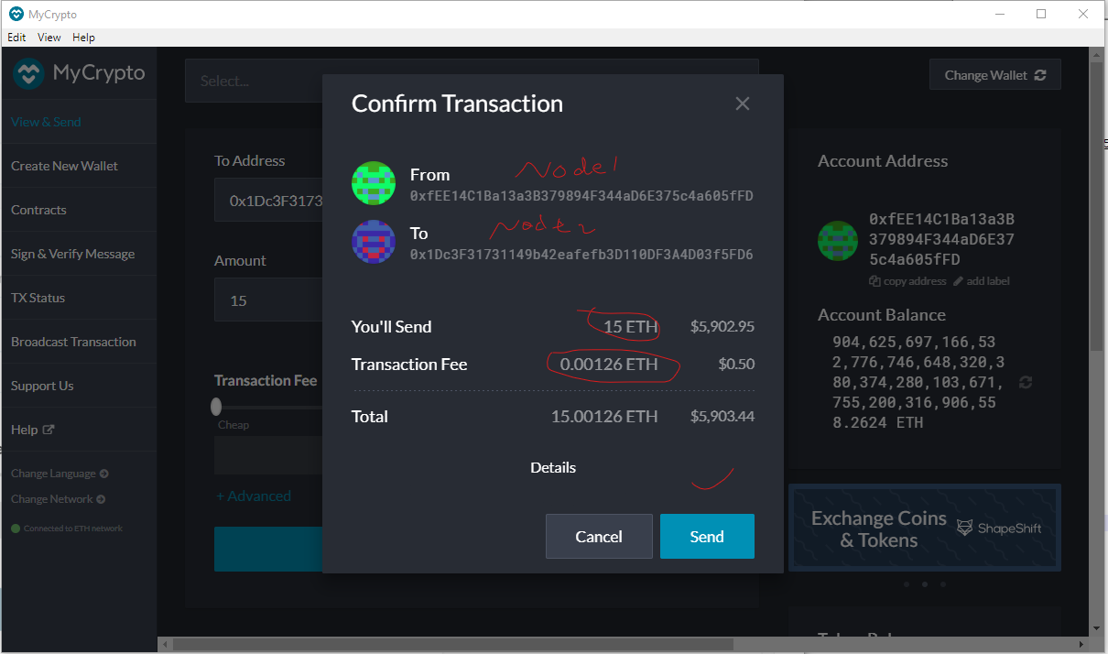

Picture showing consoles of node1 and node2

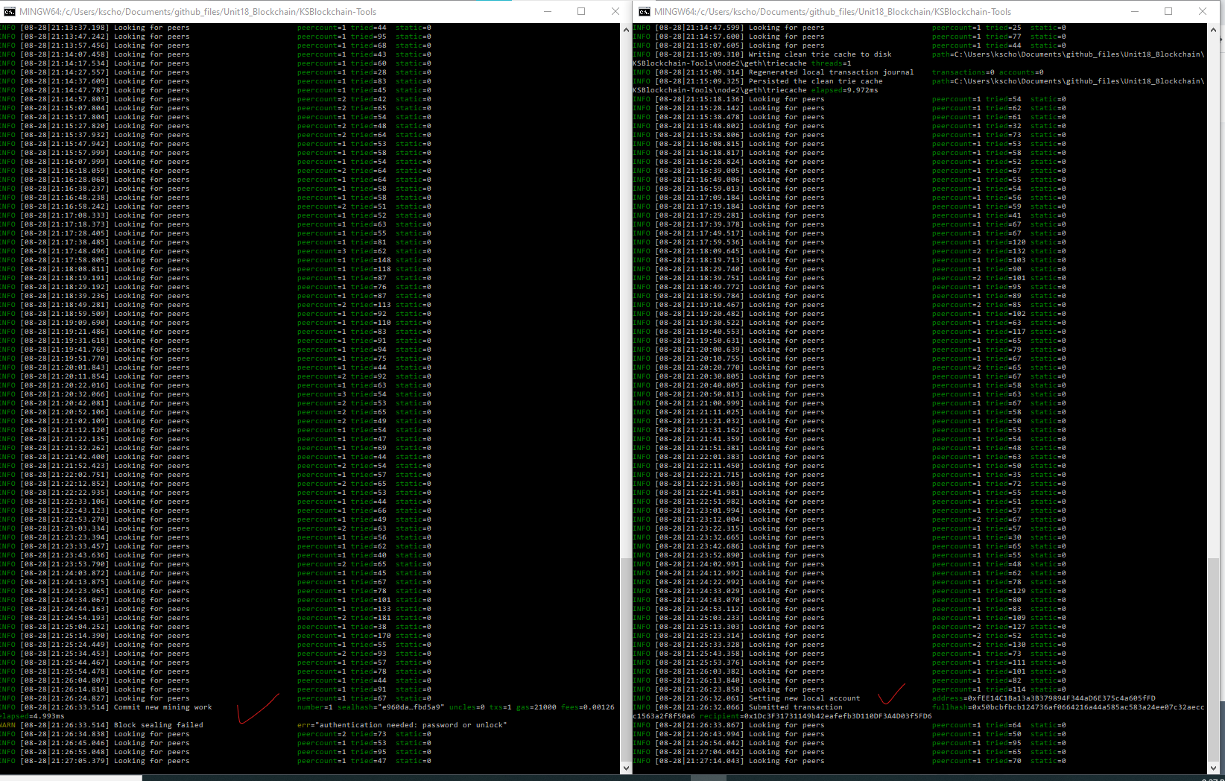

Picture showing Transfer status and Hash

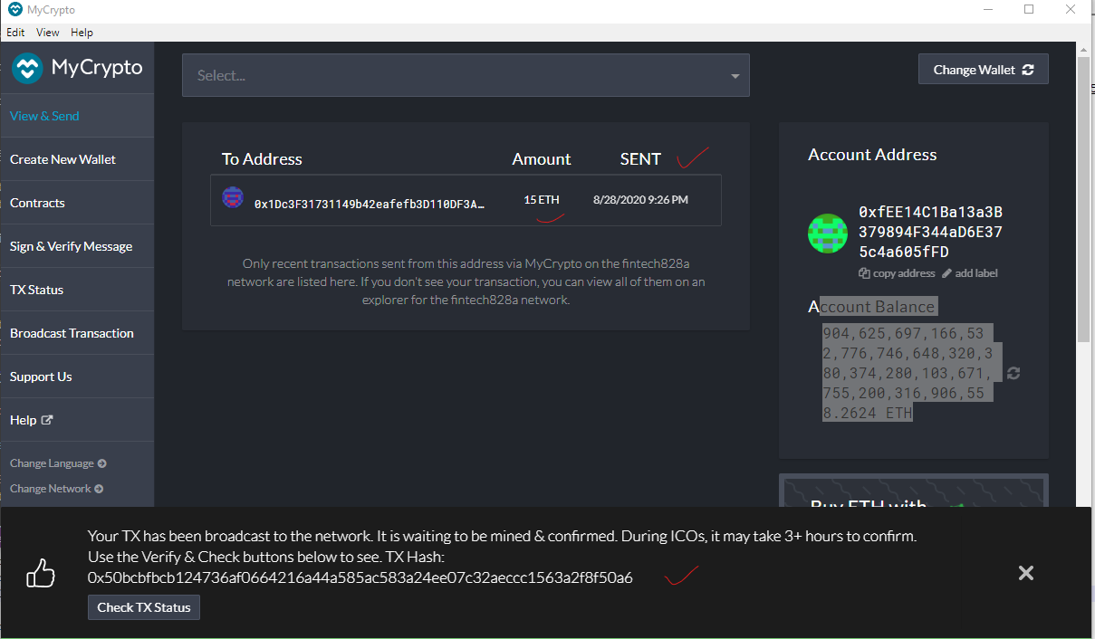

Picture showing Transfer Status (Pending)

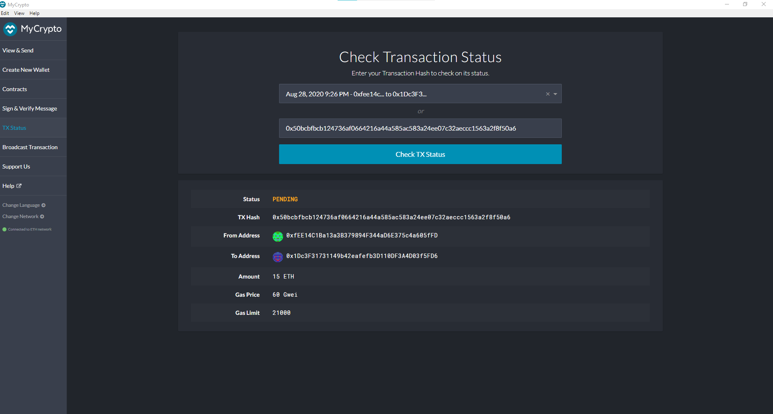

Picture showing consoles after 2nd Transfer of 25 ETH

Node1 messages: Block Sealing Failed, error: Authentication needed: password or unlock

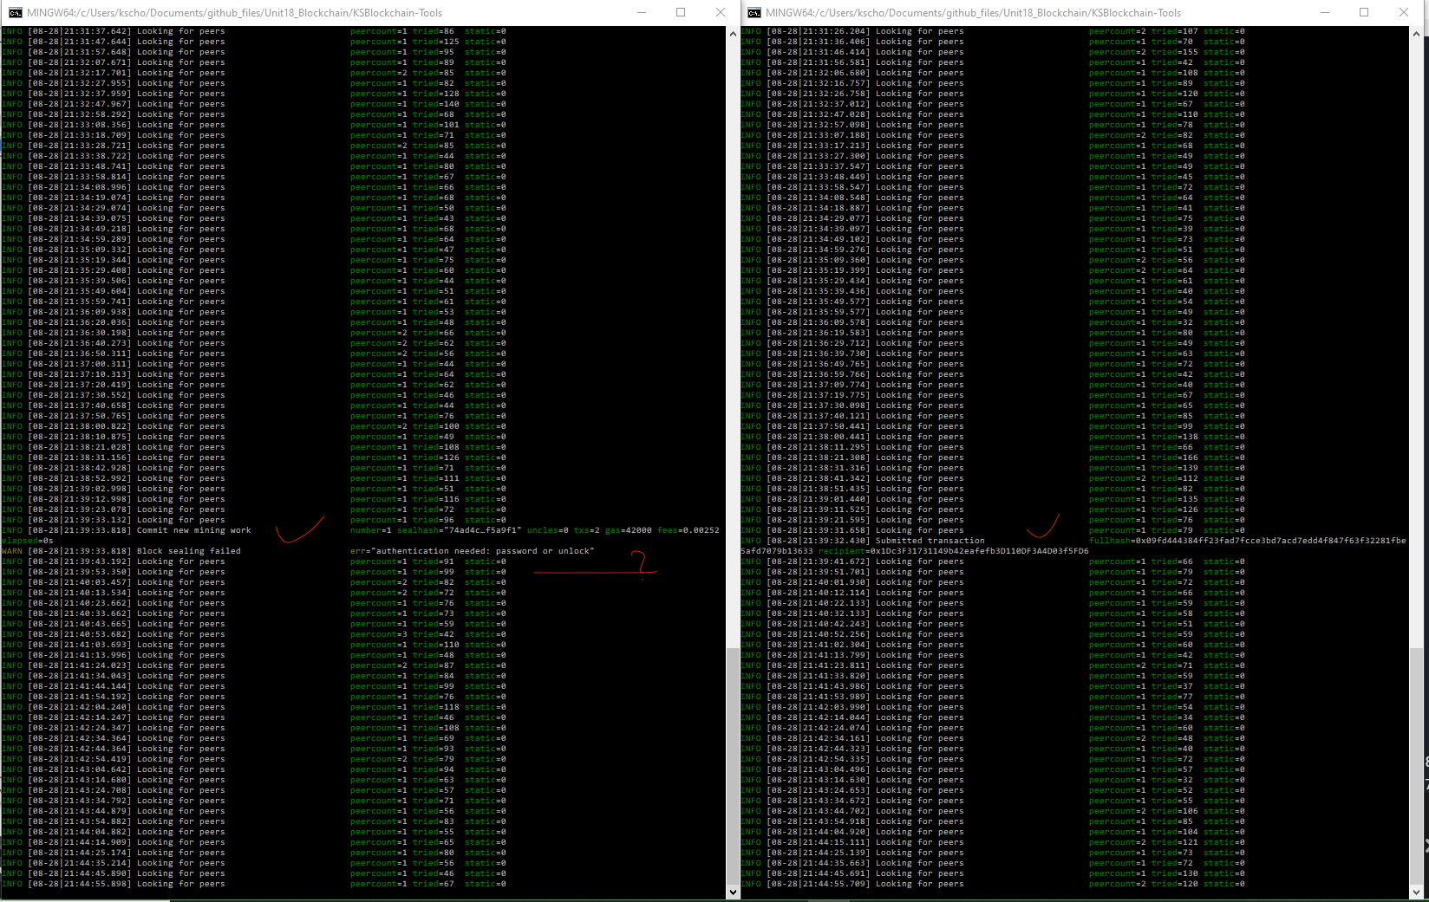

Picture showing the TX Status for 2nd Transfer of 25 ETH. This shows nonce = 1 at the bottom.

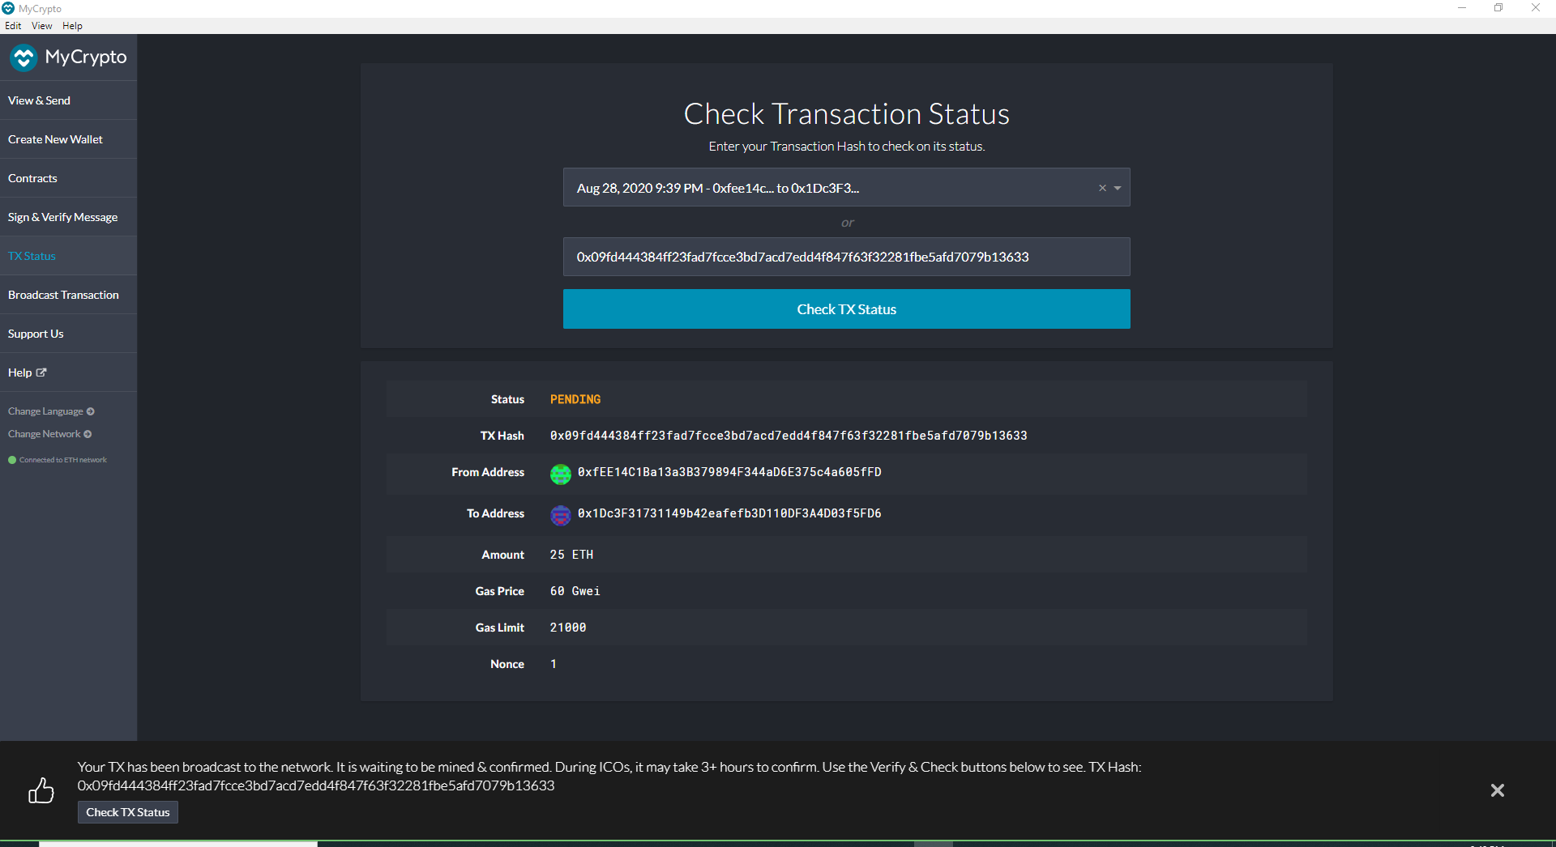

Picture showing node1 console error message

